Project Architects:
Thomas Schroeder,
…
Author:
Thomas Schroeder
January 13th, 2025
CONFIDENTIAL
Software Design


New Persistency of Long Texts in S/4HANA Sales

Contents
1. Introduction and Goal 3
2. Design 5
2.1. Status quo 5
2.1.1. Status quo: Archiving of texts (not in 2602 PoC scope) 8
2.1.2. Status Quo – Integration in VDM 9
2.1.3. Status Quo – Handling of text references 11
2.2. Integrating a new persistency into the existing framework 13
2.3. Design of the new text table 14
2.4. Migration of texts 16
2.5. Pro and Cons: Common text persistency vs distributed text persistency 16
2.6. Out of scope for the MVS 17
2.7. Limitations 17
3. Detailed Design 18
3.1. New Persistency Class(es) 18
3.1.1. READ_HEADERS_VIA_RANGES 18
3.1.2. READ 18
3.1.3. CREATE 18
3.1.4. CHANGE 19
3.1.5. DELETE 19
3.1.6. ARE_REFERENCES_HANDLED 19
3.1.7. IS_MIGRATION_FINISHED 20
3.2. Conversion methods 20
3.2.1. Plain text 20
3.2.2. HTML text 20
3.3. Integration into the legacy coding 20
3.3.1. CDS view with table function 20
3.4. Copy Controls 21
3.5. Silent Data Migration 22
3.5.1. IF_SDM_MIGRATION~MIGRATE_DATA 22
3.5.2. IF_SDM_MIGRATION~MIGRATE_DATA_FINISHED 24
3.5.3. Remaining methods 25
3.5.4. Performance considerations 25
3.5.5. Handling of the SDM-version fields in the Applications 25
3.6. Archiving (not in 2602 PoC scope) 26
3.6.1. Function group VX_TEXT_AC 27
3.6.2. Adjustments of the archiving objects 27
3.7. Integration into the VDM and RAP models 27
3.7.1. Basic view on the new text table 27
3.7.2. Integration into the RAP models 28
3.8. Test cases 28
3.8.1. Text handling in the transaction 28
3.8.2. SDM migration 29
3.8.3. Archiving (not in 2602 PoC scope) 29
3.9. Design challenges 29
3.9.1. Text CDS views from other LoBs missing 29
3.9.2. Text Reference Chain 30
3.9.3. No SDM development for Delivery-documents 31
4. Open questions and topics 31
5. References 31
6. Document History 32

Introduction and Goal
One of the technological pillars of S/4HANA is the CDS view technique. Analytical applications, list reports, BW extraction, OData services, RAP facades of business objects – all of them rely on the Virtual Data Model (VDM) of the underlying business objects which is based on CDS views. It is therefore of primary importance to integrate all components of a particular business object into the VDM.
One obstacle to this goal has so far been the persistency of long texts (sometimes also referred to as notes). Most of the applications in S/4HANA are using SAPscript as the underlying basis technology for long texts. In SAPscript, the text lines are stored in database tables STXL which is a cluster table. This table cannot be accessed via SQL directly, instead the content is only readable via the proprietary ABAP command IMPORT FROM DATABASE. This has up to now prevented the integration of long texts into the VDM without work arounds like virtual elements allowing execution of ABAP coding in the background.
The access methods used in the existing CDS-views are not suitable for the intended extraction and analytical uses cases due to limitations in the framework: AMDP table functions are not supported by CDC, virtual elements are only supported by SADL but no other frameworks based on CDC.
Applications could develop their own text handling based on a new text persistency, but this new handling would require a huge effort and lead to diverse and nonuniform text functionalities. For this reason, the SAPscript team has enabled a new functionality where applications can still use the standard SAPscript APIs to read and write long texts, thus retaining their existing application integration while switching to a new application specific transparent persistency. This approach enables the integration of long texts into the VDM, while at the same time major refactoring efforts for the individual applications are avoided:
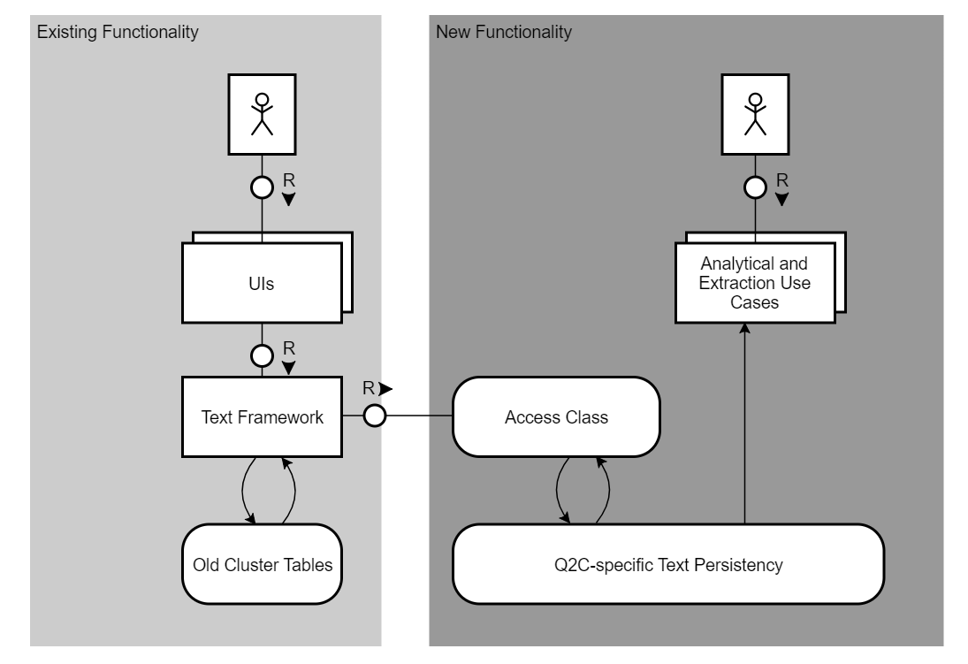
An application specific persistency which is tailored to the needs and the structure of the S/4HANA application also has the following advantages compared to the generic SAPscript tables:
- SAPscript uses a generic CHAR70 key for identifying a text. This makes a conversion necessary and JOIN operations more difficult. An application specific persistency can include properly typed key fields simplifying join conditions.
- SAPscript uses a proprietary format (ITF) which is not known or supported by external tools. With an application specific persistency, the standard formats (e.g., plain text and HTML) can be supported, and the texts can be made available for full-text search on HANA.
This document describes the implementation of the approach for S/4HANA Sales transactions based on the existing sales and billing document models to enable the desired analytical and extraction use cases.

Design

Status quo
In S/4HANA Sales, only one SAPscript text object is used across the complete process chain:
Text Object | Description
VBBK | Sales Header texts
VBBP | Sales Item texts
The following text objects are not part of the PoC:
- WCOCOCOND
- WCOCOH
- WCOCOI
- WCOCOP
- Condition Contract Conditions
- Condition Contract Header
- Condition Contract Item
- Condition Contract Partner
- VBKA Sales CAS texts
- VBRK
- VBRP
For text objects VBRK and VBRP, they are not used productively in SD Billing, this is confirmed by Maximilian Denne. For SD Billing, it is expected that separated text objects are used in the new design originally, but this option was dismissed in alignment with PM and engineering as the cost/benefit ratio is most likely too bad.
The primary entity table of the text objects is TTXOB (software component SAP_BASIS, package STXD). The actual text objects are maintained in transaction SE75, the determination is maintained via transaction VOTXN.
The actual text content is stored in STXH and STXL, e.g. for Sales Quotation header and item texts:
Text in GUI.
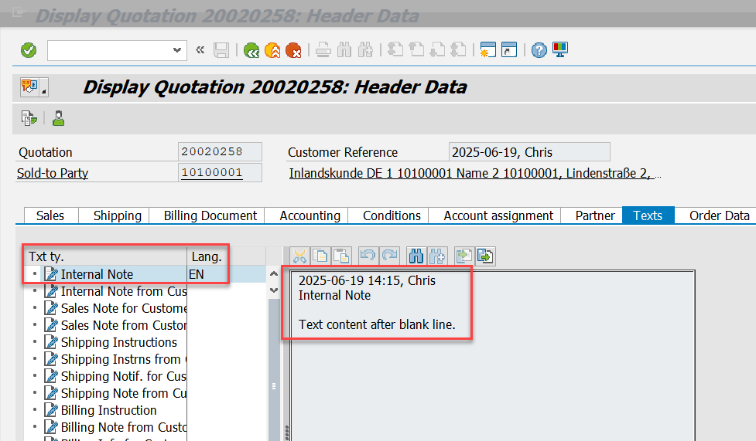

Text in table STXH.
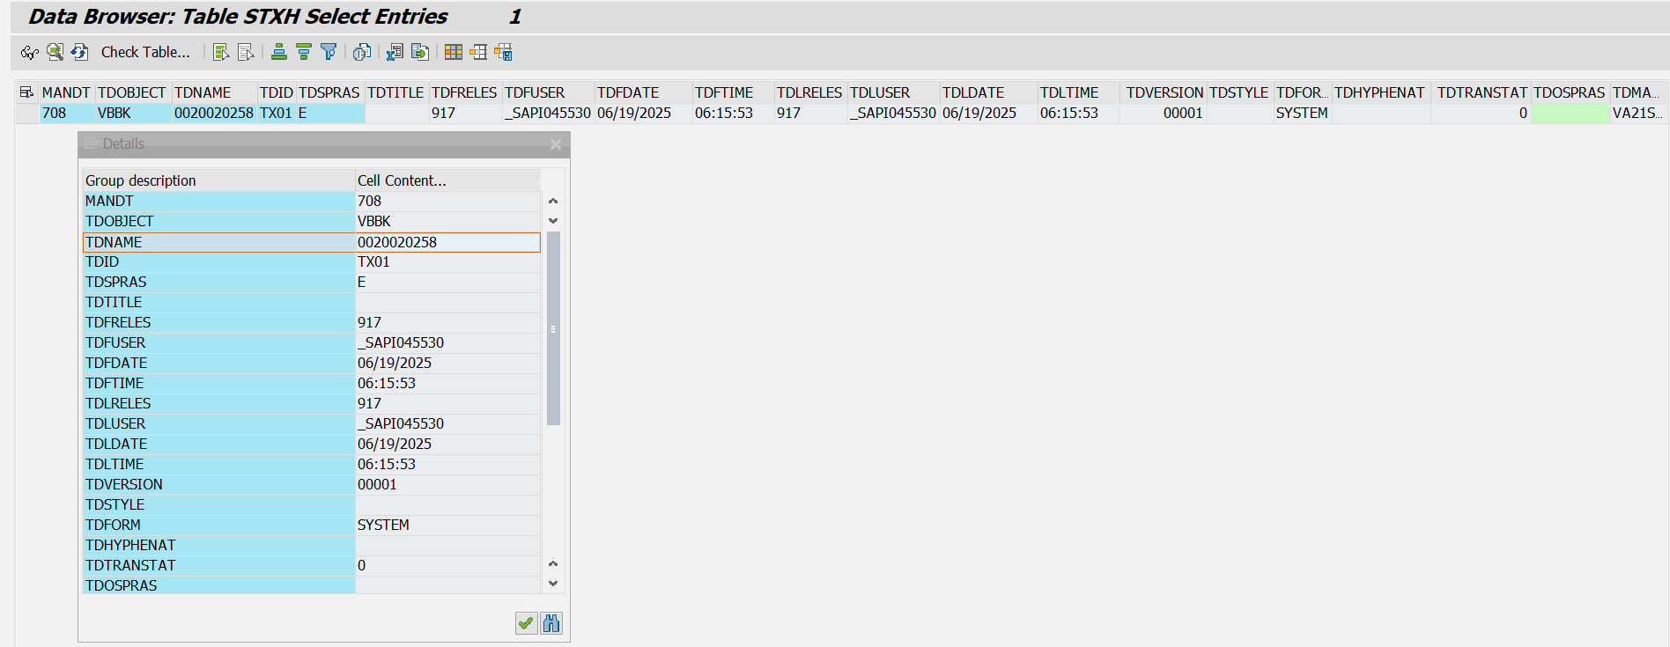

Text in table STXL.
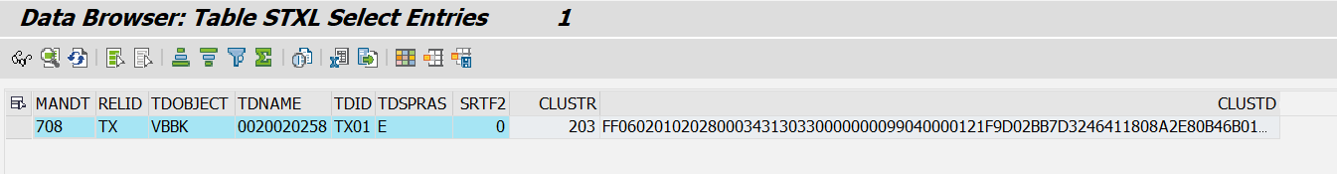

Other examples.
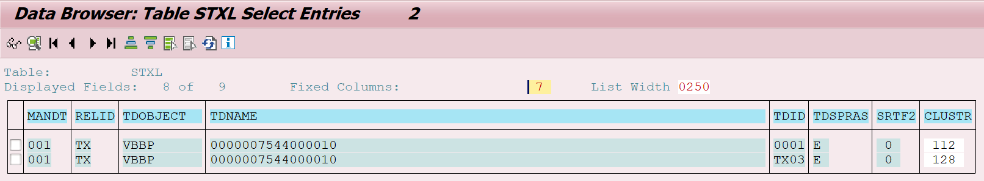

Text header information.
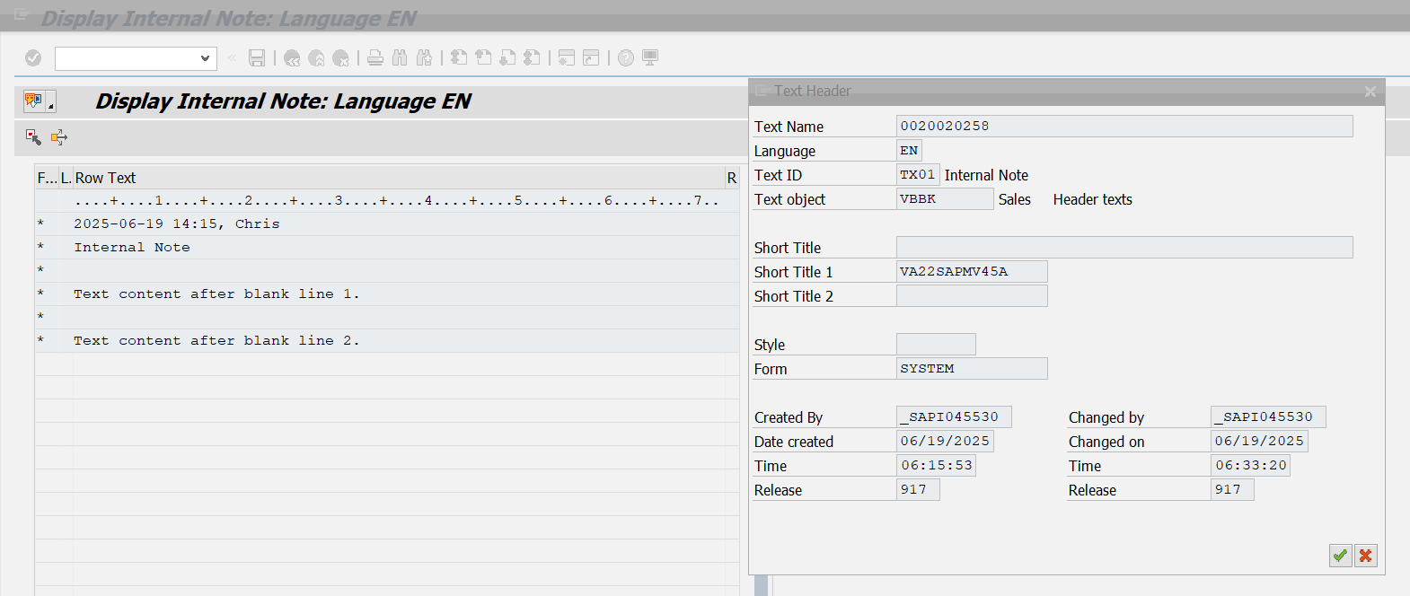
The leading table STXH has the following structure:
 | Key | Data Element | Data Type | Length | Description
MANDT | X | MANDT | CLNT | 3 | Client
TDOBJECT | X | TDOBJECT | CHAR | 10 | Texts: application object.  For SD application, it is VBBK or VBBP.
TDNAME | X | TDOBNAME | CHAR | 70 | Text Name.  For header text, it is SD document ID with leading zero.  For item text, it is SD document ID plus item ID with leading zero.
TDID | X | TDID | CHAR | 4 | Text ID
TDSPRAS | X | SPRAS | LANG | 1 | Language Key
TDTITLE |  | TDTITLE | CHAR | 50 | Title in dialog box
TDFRELES |  | TDFRELES | CHAR | 4 | Release
TDFUSER |  | TDFUSER | CHAR | 12 | Created by
TDFDATE |  | TDFDATE | DATS | 8 | Date created
TDFTIME |  | TDFTIME | TIMS | 6 | Time Created
TDLRELES |  | TDLRELES | CHAR | 4 | Last Changed in Release
TDLUSER |  | TDLUSER | CHAR | 12 | Last changed by
TDLDATE |  | TDLDATE | DATS | 8 | Changed On
TDLTIME |  | TDLTIME | TIMS | 6 | Last Changed At
TDVERSION |  | TDVERSION | NUMC | 5 | Version
TDSTYLE |  | TDSTYLE | CHAR | 8 | Style Name
TDFORM |  | TDFORM | CHAR | 16 | Form name
TDHYPHENAT |  | TDHYPHENAT | CHAR | 1 | Hyphenation Active
TDTRANSTAT |  | TDTRANSTAT | NUMC | 1 | Translation status
TDOSPRAS |  | TDOSPRAS | LANG | 1 | Original language
TDMACODE1 |  | TDMACODE1 | CHAR | 16 | Short Title 1
TDMACODE2 |  | TDMACODE2 | CHAR | 16 | Short Title 2
TDTXTLINES |  | TDTXTLINES | NUMC | 5 | Number of Text Lines in Line Table
TDREF |  | TDREF | CHAR | 1 | Reference text
TDREFOBJ |  | TDREFOBJ | CHAR | 10 | Object of Referenced Text
TDREFNAME |  | TDREFNAME | CHAR | 70 | Name of Referenced Text
TDREFID |  | TDREFID | CHAR | 4 | ID of Referenced Text
TDTEXTTYPE |  | TDTEXTTYPE | CHAR | 6 | SAPscript: Format of Text
TDCOMPRESS |  | TDCOMPRESS | CHAR | 1 | SAPscript: Text is compressed
TDOCLASS |  | TDOCLASS | CHAR | 4 | SAPscript: Object Class
LOGSYS |  | LOGSYS | CHAR | 10 | Logical system

The actual text lines are stored in table STXL having the following structure:
 | Key | Data Element | Data Type | Length | Description
MANDT | X | MANDT | CLNT | 3 | Client
RELID | X | SYCHAR02 | CHAR | 2 | CHAR02 data element for SYST
TDOBJECT | X | TDOBJECT | CHAR | 10 | Texts: application object
TDNAME | X | TDOBNAME | CHAR | 70 | Name
TDID | X | TDID | CHAR | 4 | Text ID
TDSPRAS | X | SPRAS | LANG | 1 | Language Key
SRTF2 | X | SYBIN1 | INT1 | 3 | BIN1 data element for SYST
CLUSTR |  | SYBIN2 | INT2 | 5 | BIN2 data element for SYST
CLUSTD |  | STXLDUMMY2 | LRAW | 7902 | SAPscript: LONG RAW field for table STXL

Status quo: Archiving of texts (not in 2602 PoC scope)
Texts are included in archiving sales documents with archiving object SD_VBAK (=> Archiving program S3VBAKWRS) using archiving class TEXT (SAPscript). This is assigned to archiving object SD_VBAK in transaction AOBJ under Archiving Classes used (ACLA):
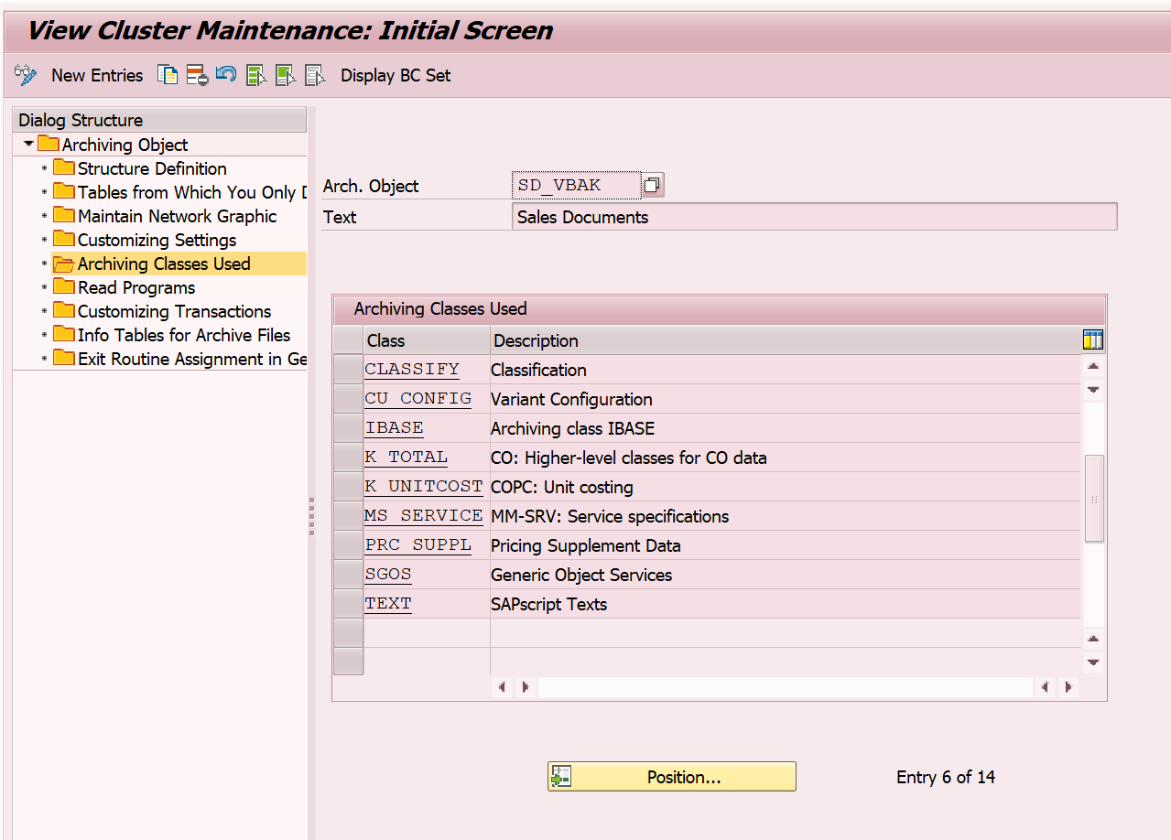

Archiving class TEXT is handling everything like resolution of text references, copying referenced text, etc. We call the function module TEXT_ARCHIVE_OBJECT belonging to this archiving class in archiving program S3VBAKWRS from FORM BELEGE_ARCHIVIEREN_WRS:

All texts are thus written to the archive file.
DATA: textname LIKE thead-tdname.
….

stxh-tdid = '*'.
stxh-tdspras = '*'.
textname = '?1*'.
REPLACE '?1' WITH xvbak-vbeln INTO textname.
CALL FUNCTION 'TEXT_ARCHIVE_OBJECT'
EXPORTING
archive_handle = if_archive_handle
client = sy-mandt
id = '*'
language = '*'
name = textname
object = 'VBBK'
object_delete_flag = 'X'.
CALL FUNCTION 'TEXT_ARCHIVE_OBJECT'
EXPORTING
archive_handle = if_archive_handle
client = sy-mandt
id = '*'
language = '*'
name = textname
object = 'VBBP'
object_delete_flag = 'X'.

Function module ASH_ SD_VBAK_READ is used to read texts from the archive (for example in VA03 or within transaction SARI) This is reading texts from the archive and puts it into SAPScript memory for later use. This is done via SAP Script function modules like SELECT_TEXT. These function modules can all read from the archive.
For invoices the implementation follows a similar pattern via registering class TEXT to archiving object SD_VBRK and Form routine BELEGE_ARCHIVIEREN in archiving program S3VBRKWRS.
Potential example in system EER Client 003: SARI, Archive Explorer: SD_VBAK, Info structure SAP_VBAK_ERDAT. Execute, execute and display document 230804.

Status Quo – Integration in VDM
The current integration is done via a table function in sales and billing. Sales is using CDS-view P_SalesDocumentText:

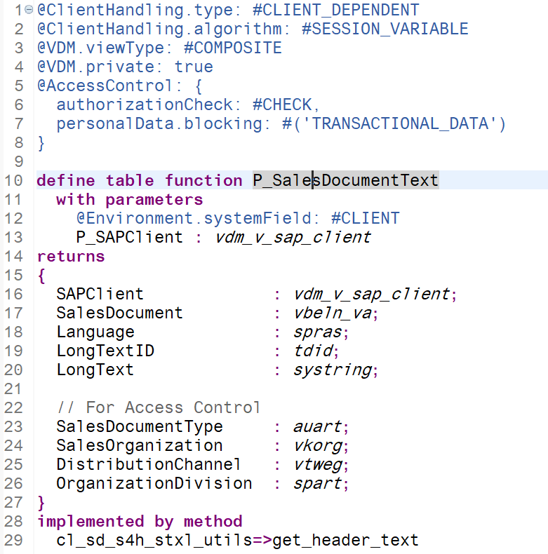
The item texts are read in the same pattern via view P_SalesDocumentItemText
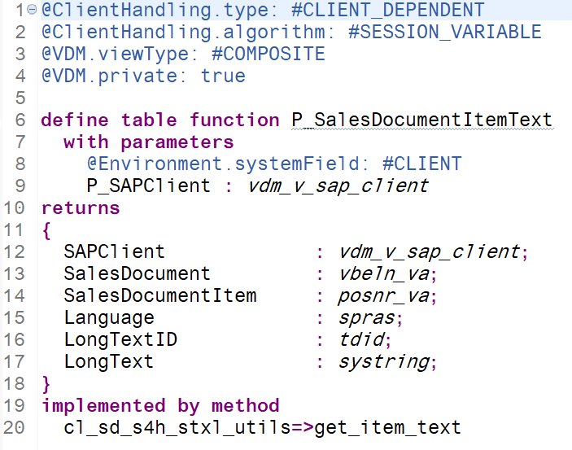
CL_SD_S4H_STXL_UTILS is providing separate methods for item and header texts.
Billing is applying a similar pattern in view P_BillingDocumentText, but does not distinguish between header and item data in the view:
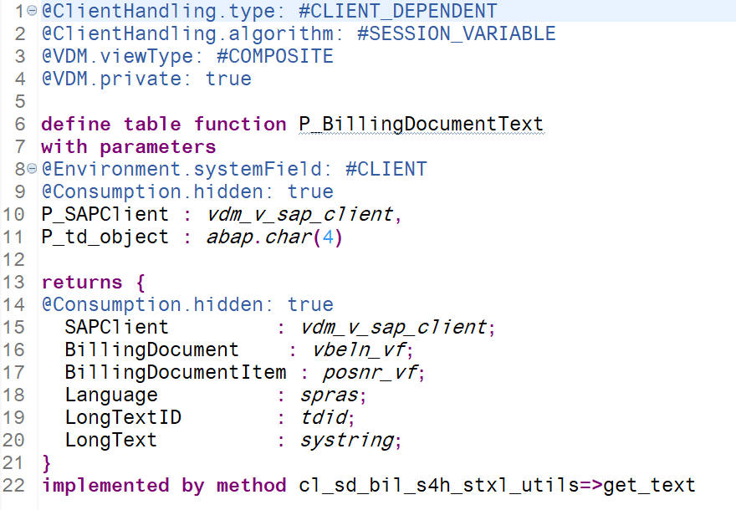
Class CL_SD_BIL_S4H_STXL provides only one method that reads both VBBK and VBBP.
These P-Views are then reused in the data definitions of RAP layer, for example in R_SalesOrderItemTextTP:

Status Quo – Handling of text references
The existing text functionality allows not only copying texts but also referencing texts. A reference is activated in transaction VOTXN on text procedure level using flag Refer/Duplicate. In the following example text IDs 0002 and 0003 would be referenced while text IDs 0004 and 0005 would be copied.
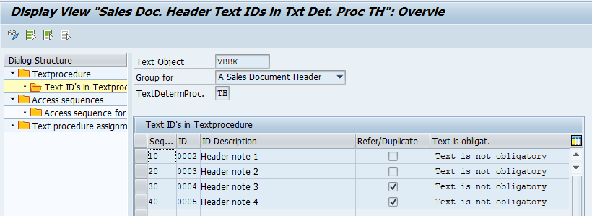
In case a text is referenced, the original text is stored in STXH using fields TDREF, TDREFOBJ, TDREFNAME, and TDREFID. The exact behaviour of references in a document chain depends on the access sequence defined for the text IDs defining the priority of possible sources for a text.
In the given example text ID 0002 is using access sequence 998 defined as
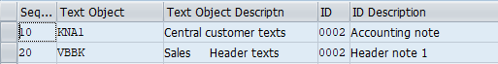
Here, KNA1 has higher priority followed by VBBK with lower priority. Text ID 003 is using access sequence 999 instead which has a different order of priority for the sources. Here VBBK has priority over KNA1:
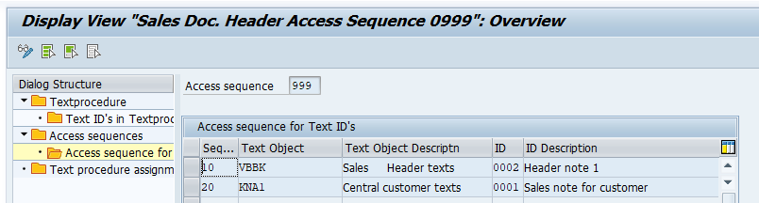
The standard pattern for delivered access sequences used by Q2C is similar to the pattern used in access sequence 999 as usually a “specialization” of a text in a document should have precedence over the more “generic standard proposal” in the master data, but it depends on the individual use case for the text.
The texts in text object KNA1 used for the example are:
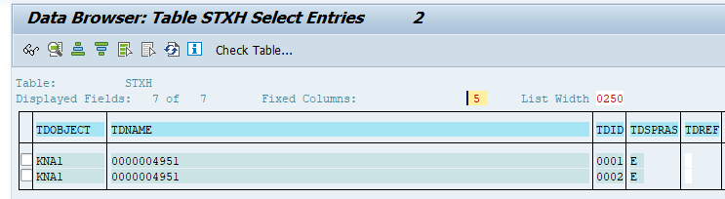
Within an example document chain Inquiry -> Quotation -> Sales Order the references in STXH based on this KNA1 example data would be as follows for the non-standard-like pattern used in access sequence 998:
Business Object | TDOBJECT | TDNAME | TDID | TDREF | TDREFOBJ | TDREFNAME | TDREFID
Inquiry | VBBK | 10000000 | 2 | X | KNA1 | 4951 | 2
Quotation | VBBK | 20000000 | 2 | X | KNA1 | 4951 | 2
Sales Order | VBBK | 3 | 2 | X | KNA1 | 4951 | 2

Here, all objects use the original KNA1-text as direct reference. All texts reference the same text.
In the standard like pattern used for text ID 0003 the references used are:
Business Object | TDOBJECT | TDNAME | TDID | TDREF | TDREFOBJ | TDREFNAME | TDREFID
Inquiry | VBBK | 10000000 | 3 | X | KNA1 | 4951 | 1
Quotation | VBBK | 20000000 | 3 | X | VBBK | 10000000 | 2
Sales Order | VBBK | 3 | 3 | X | VBBK | 20000000 | 2

Here each document is referencing the preceding document and only the initial document references the original text. This means we have usually a chain of references master data <- first document <- second document <- third document <-… which makes resolution of these text chains impossible via JOINS in CDS as there might be an arbitrary number of levels. This can only be resolved by consumers of the CDS view following the reference programmatically.

Interestingly, the standard allows the deletion of referenced texts:
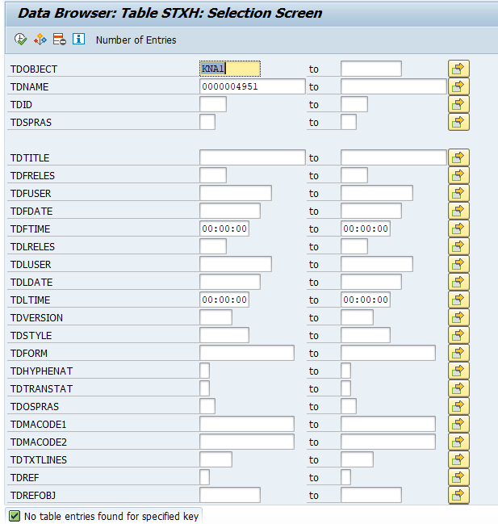

After deletion, the references in VBBK continue to point to the old, now nonexistent texts:
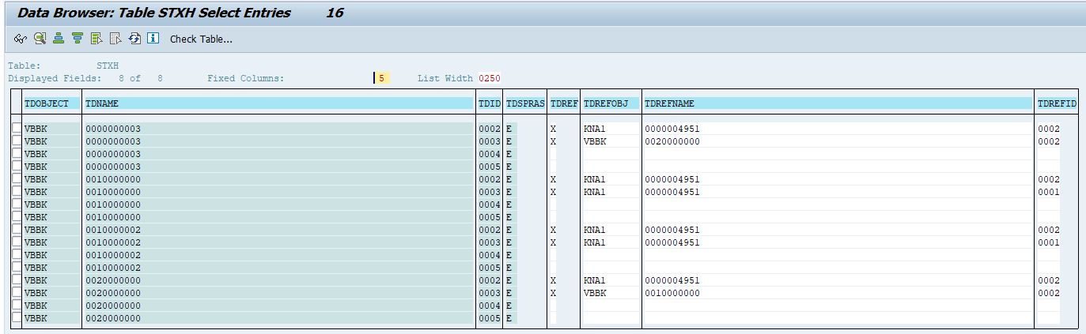

Integrating a new persistency into the existing framework
This Wiki page describes the integration of an application specific text persistency into the SAPscript framework. We will not repeat all required implementation steps, but summarize the main points:
- The application has to provide a class which inherits from the basis class CL_RSTXT_PERSISTENCE_FRAMEWORK. The following methods have to be redefined and implemented by the application:
  - READ_HEADERS_VIA_RANGES (Read several text headers; key is provided via ranges tables)
  - READ (Read a single text (header and content))
  - CREATE (Create a new text)
  - CHANGE (Change an existing text)
  - DELETE (Delete a single text)
- The design of the transparent text persistency is the task of the application. This is described in the next section.
- The new persistency can be activated on text object level (table TTXOB) or on text ID level (table TTXID) by entering the persistence handler class defined in step 1 in the field HANDLER_CLASS. For this project the new persistence handler class will be registered for text objects VBBK and VBBP, this means all the SD documents’ header and item texts will be impacted by this registration.
This last point (activation of the new persistency) has an important consequence: Since the tables TTXOB and TTXID are client-independent and have delivery class E, the switch is done centrally by SAP, it is common for Cloud and OP customers, and it cannot be overruled by customers. There is no possibility to influence this via customizing or distinguish between Cloud and OP. Thus, it immediately takes effect in customers’ systems when delivered. Regarding the migration of existing texts, this will be described in section ‎3.4.

For entries in TTXOB, there is no possibility to influence this via customizing or distinguish between Cloud and OP. The current SDD is for Public Cloud only. Table TTXOB is part of the platform, but the entries are defined by the applications. We can adapt the entries for VBBK/VBBP in ER1 only. If needed, we may have to relocate the registered GTABKEY value to reflect ER1 as the suitable original system for these entries for Public Cloud.

Design of the new text table
In this section we present the proposed design of the new text table. The following aspects have been considered in the design:
- Currently, texts are stored on different levels: There are texts on header and on item level. This suggests not introducing a fixed primary key but working with a UUID as primary key and provide the logical key fields in the data part.
- To support full-text search on HANA, a field MIMETYPE with data element NTE_MIMETYPE must be provided.
- The text content itself is modelled as a string. After the conversion, the ITF format text will be converted to plain text with no format. The text content data will be exposed via CDS view, for CDS view consumers the easiest way is consuming plain text.
- The customizing option of referencing texts from another object instead of copying them to the target object must be preserved, therefore we also need the key fields of the reference text in the table.
- Ideally, the option of supporting formatting in an HTML editor should be introduced to support standard MIME types. Texts with formatting will be converted into an HTML text string (a corresponding conversion method is already in place in CRM solution) and stored with MIME type text/html. Texts without formatting will be stored with MIME type text/plain.
- The administrative fields created at, created by, changed at, changed by are required for the display of log texts.

This leads to the following proposed design options:

Option 1, preferred option as using UUID as table key we have more flexibilty on table design, all the SD text data will be saved in this table. To improve the performance of CDS views based on this new table, it is discussed that fields used for SD document authorization check should also be part of the SD text table, with those fields the text CDS views could work independnt of host CDS views.

- Package: SD_BF_TEXT_DET, Application Component SD-BF-TP.
- Table Name: SDTP_TEXT.
- Delivery class: A
- Size Category: 9 (different from the size setting for table STXH which is 4, but same to the setting for table VBAP).
Field | Key | Data element | Description
MANDT | X | MANDT | Client
SD_TEXT_UUID | X | SD_TEXT_UUID | UUID of the SD text
SD_DOCUMENT |  | VBELN | SD Document ID  Index on this field.
SD_DOCUMENT_ITEM |  | POSNR | SD Document Item ID
TEXT_NAME |  | TDOBNAME | Text Name
TEXT_OBJECT |  | TDOBJECT | Text object
TEXT_ID |  | TDID | Text ID
TEXT_LANGUAGE |  | SPRAS | Language
MIMETYPE |  | NTE_MIMETYPE | MIME type
TEXT_CONTENT |  | (built-in type STRING) | Text content
REF_FLAG |  | TDREF | Reference flag
REF_TEXT_NAME |  | TDREFNAME | Text name of referenced text
REF_TEXT_OBJECT |  | TDREFOBJ | Text object of referenced text
REF_TEXT_ID |  | TDREFID | Text ID of referenced text
SD_DOCUMENT_CATEGORY |  | VBTYPL | SD Document Category
SALES_DOCUMENT_TYPE |  | AUART | Sales Document Type
BILLING_DOCUMENT_TYPE |  | FKART | Billing Document Type
SALES_ORGANIZATION |  | VKORG | Sales Organization
DISTRIBUTION_CHANNEL |  | VTWEG | Distribution Channel
DIVISION |  | SPART | Division
SHIPPING_POINT |  | VSTEL | Shipping Point
CREATED_AT |  | SD_TEXT_CREATED_AT | Created Timestamp
CREATED_BY |  | TDFUSER | Created by
CHANGED_AT |  | SD_TEXT_CHANGED_AT | Changed Timestamp
CHANGED_BY |  | TDLUSER | Changed by

Option 2
VX_TEXT_2(VBR_TEXT/…) |  | Delivery class: A
Field | Key | Data element | Description
MANDT | X | MANDT | Client
SD_DOCUMENT | X | VBELN | Document Number
SD_DOCUMENT_ITEM | X | POSNR | Item Number
TEXT_OBJECT | X | TDOBJECT | Text object
TEXT_ID | X | TDID | Text ID
LANGUAGE | X | SPRAS | Language
MIMETYPE |  | NTE_MIMETYPE | MIME type
TEXT_CONTENT |  | (built-in type STRING) | Text content
REF_TEXT_OBJECT |  | TDREFOBJ | Text object of referenced text
REF_TEXT_ID |  | TDREFID | Text ID of referenced text
REF_TEXT_NAME |  | TDREFNAME | Name of referenced text
CREATED_AT |  | SD_TEXT_CREATED_AT (new) | Created at
CREATED_BY |  | SD_TEXT_CREATED_BY (new) | Created by
CHANGED_AT |  | SD_TEXT_CHANGED_AT (new) | Changed at
CHANGED_BY |  | SD_TEXT_CHANGED_BY (new) | Changed by

It was discussed whether the MIME type should be part of the key in Option 2, but the assumption is that each individual text ID corresponds to one MIME type. Option 1 would allow this as the technical key is a GUID which will differ in case different MIME types are used.

It was discussed to use SSTRING but STRING in combination with a MIME type field using NTE_MIMETYPE are required by enterprise search to deal with formatted texts.

We need the fields TEXT_OBJECT, TEXT_ID and REF_TEXT_NAME which points to referenced text records.

An index will be created on the field SD_DOCUMENT. Note that only indices with exactly one field are unproblematic in HANA; more fields create much more overhead thus we do not create an index including field SD_DOCUMENT_ITEM. The assumption is that reading on document level should be fast enough to simplify the retrieval of texts for a given document.

 | Pro | Cons
GUID | More flexible  Would allow different MIME types out of the box
Individal Key fields | Closer to other SD/LE-Table designs | Less flexible  Key does not allow multiple mime types, not future proof

Migration of texts

Obviously, it is desirable to transfer all existing long texts to the new persistency to make them available in the RAP model and thus applications and use cases based upon RAP such as OData V4 services or Fiori apps. To execute and control the conversion a new Silent Data Migration (SDM) class is needed as SDM is the only available option for conversions in public cloud due to the zero down time requirements. To assess the status an indicator SDM_VERSION to indicate the SDM status separated for VBAK, VBRK and LIKP has to be introduced.

If the SDM has not been completed successfully in all clients, the SAPscript APIs will write into both persistencies (STXH/STXL as well as the new transparent table), and they will read from the old persistency. Only if the SDM has finished successfully, the old persistency is no longer used for writing or read access. To support this, another method IS_MIGRATION_FINISHED will be provided in class CL_RSTXT_PERSISTENCE_FRAMEWORK which can be overwritten by the application persistence class. This logic replaces the optional parameter USE_OLD_PERSISTENCE in the APIs SELECT_TEXT and READ_TEXT. This is a big benefit because it implies that the calls of SELECT_TEXT and READ_TEXT do not have to be modified.

Also, an on-the-fly migration of texts during transactional processing is not required with this approach. When a text is created or changed in an existing transaction which is not yet migrated, this text will be stored in both persistencies. But there is no need to migrate the untouched texts of this transaction on the fly. The transaction would still have the field SDM_VERSION with original value and would be picked up by the SDM class. The migration method converts all SAPscript texts (also the one which is already existing in the new persistency) to the new table. But before performing the INSERT into the new table, a DELETE is executed for the new table, i.e., all texts which might already exist in the new table for the specified SD documents are deleted. This is required anyway for a restart of the SDM process. This logic ensures that the converted texts are not stored multiple times. For details, see section 3.5.

Any data conversion performed must consider the performance strongly since the involved database tables contain very high volume data.

Pro and Cons: Common text persistency vs distributed text persistency
There are two general possibilities to introduce a new text persistency:
- Continue to reuse one text object for the complete process chain like the reuse of VBBK and VBBP
- Define individual text objects per modernization areas Core Sales, Delivery Management in Logistics Execution, and Core Billing

 | Pro | Cons
Reuse | Less effort  Better aligned with handling of mapping class in central text layer  Less impact on application coding.  Less risk of day1 impact for text determination.
Split | Allows for more flexibility per modernization area.  Smaller table sizes and probably better performance.  Slightly easier data model  Better separation of ACL-Fields | Not aligned with handling of mapping class in central text layer: Probably mapping class must be implemented as wrapper class  Would probably require new text objects VBRK_TEXT, VBRP_TEXT, VBAK_TEXT, VBAP_TEXT, …. with additional risks and efforts.

While the split of the text objects into separate layers is more complicated it is not impossible, but would require a wrapper class to be entered into the mapping registry that orchestrates the distribution into separate persistence layers for sales, delivery and billing. Each persistence layer could be modeled in the same pattern. Advantages would be a smaller table size per area and simplification of the data model as each data model within a modernization area could access.

Introducing new text objects would require a migration/distribution of existing entries in VBBP/VBBK into these new text objects. It would also require a migration of the text determination to provide compatible determination for these new objects instead of the old objects VBBP and VBBK. Splitting the text persistence while keeping the old text objects would require complex logic to determine which persistence should be accessed for which objects.

The split option was dismissed in alignment with PM and engineering as the cost/benefit ratio is too bad. Known requirements can be fulfilled with a common text object and the effort to implement separate text objects is much higher.

Out of scope for the MVS
- Support of HTML format.
- Split of text objects (see 2.5)

Limitations
- Text references:
  - References to non-SD text data (e.g. BP text, Material text, Procument text) cannot be resolved within the extraction/analytical CDS view as these texts would still reside in the cluster table which cannot be accessed without virtual elements.
  - References within the process chain cannot be resolved within the extraction/analytical CDS view as there might be an arbitrary number of levels.

Detailed Design

New Persistency Class(es)
The new persistency class shall be named CL_SD_TEXT_PERSISTENCY. The class itself and all other objects related to the new persistency will be placed in the package SD_BF_TEXT_DET on ACH-component SD-BF-TP.
We sketch the logic of the methods that must be implemented according to the SAPscript Wiki page.

READ_HEADERS_VIA_RANGES

The interface contains a fixed text object and RANGES tables for ID, name, and language. In SD area, TDNAME is SD document number (VBELN) for header text, and it is the concatenated value of SD document number and item number for item texts.

A select will be performed on the new table base on the given text object, text ID, text name and language (in format of range table) and the text records’ header information will be returned via table type structure T_HEADER_TABLE.

READ
This method reads the text content of a single text, given by text object, text ID, text name, and text language.
- Select text from the new persistence (using the fields text object, text ID, language, logical key) and append it to the application text buffer.
- Fill the exporting structure HEADER, and the table TEXT_LINES (in ITF format) , the ITF format text is converted from string type text content via FM CONVERT_STREAM_TO_ITF_TEXT.

There is one special aspect: When the text is a reference text ( which means the fields REF_TEXT_OBJECT, REF_TEXT_ID and REF_TEXT_NAME are filled), the READ method must return the text lines of the reference text. For this purpose, the convenience method CL_RSTXT_PERSISTENCE_MANAGER=> RESOLVE_REFERENCE is provided which yields the text lines of the reference text and automatically takes care of the cases where the reference text is in the old or already in a new persistency.

CL_RSTXT_PERSISTENCE_MANAGER=>RESOLVE_REFERENCE supports multiple level text retrieve (chained reference), it will iterate the text resolution from the provided starting point automatically.
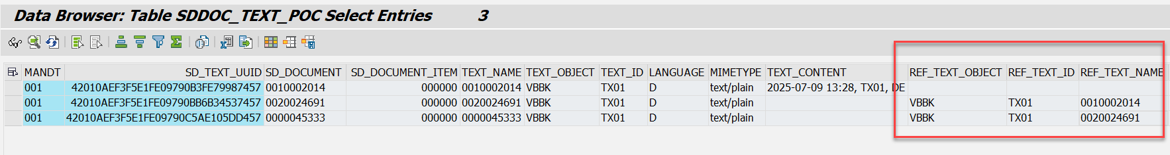

CREATE
This method creates a new text in the new persistence.
The method CREATE will be called by text framework in text creation scenario. The text framework provided the following two parameters for application processing:
- HEADER, the type is THEAD, it contains the generic info for the text, including text object, text id, text name, text language, text title, created by, created date, created time, etc. For text name, the value is document id for header text, the value is document id plus item id for item text.
- TEXT_LINES, the type is TLINE_TAB, it contains the text lines info including text format, it is the ITF format.
A generated GUID will be served as key for the text record in the new persistence.
The text header info will be saved into new persistence, including text object, text id, text name, text language (logic key of the text). The referenced text info needs to be saved in case of references, including reference text name, referenced text object, referenced text id. The MIME type will also be saved to prepare for future use cases without the need of additional conversions, but for the MVS bases on current SD scenarios text/plain is supported only.
The function module CONVERT_ITF_TO_STREAM_TEXT will be used to convert the text from ITF format to string table, then the application could save the string data (text content) into new persistence.
In case of reference scenario, the input parameter TEXT_LINES will be set to initial by text framework, the reference text info will be passed by input parameter HEADER, the related fields are TDREFOBJ, TDREFID and TDREFNAME, the reference text info will be stored in new SD text table.
Separated logical key fields for SD documents will be built into the new SD text table, including SD_Document_ID, SD_Document_Item_ID. The information could be derived from text name from input parameter HEADER.
The field text title in text header (THEAD-TDTITLE) will be used to pass auth info from application buffer to the handler class(for detail refer to chapter 3.3.2), decoding logic will be built in create method for the value in field text title and persist the auth info into respective fields. This part could not be reused by Sales, Billing and Delivery, the reason is different fields are used for auth check, the respective decode logic could be bulit in utility class.
The administrative info should also be saved to the new persistence, including created by, created date, created time.

CHANGE
This method updates a single text on the database.
- TEXT_CONTENT
- CHANGED_BY, CHANGED_AT
- The value in the reference fields (REF_TEXT_OBJECT, REF_TEXT_ID, REF_TEXT_NAME) will be cleared. This is because in change mode a referenced text is overwritten, then there is no reference to the original text.

DELETE
This method deletes a single text from the database.
In the reference scenario, in case the text is being referenced, we have following two options:
- Option A, raising a veto to prevent the deletion. Report the message in update task? But this will lead to leading text could not be deleted until all the subsequent texts been deleted/archived.
- Option B, allow the deletion, but before the deletion, all the referenced text entries should be filled will ‘real’ text content (break the linkage).
For both options, we need to check cross applications and new/old persistence…
In PoC phase, the text will be deleted directly.
Like the existing behavior of references (see chapter 2.1.3) texts will be deleted without considering text references. Similar to other SDMs, existing inconsistencies will not be resolved, but kept.

ARE_REFERENCES_HANDLED
This method must be implemented when the new text persistency is capable of handling reference texts. VX_TEXT is designed in this way, so the method simply returns abap_true.

IS_MIGRATION_FINISHED
The migration status is retrieved with the help of the SDM API CL_SDM_PROC_STATUS_API=> IS_SDM_FINISHED.

If ABAP_FALSE is returned, this has the following effects,
- All function modules which read text headers or texts (like SELECT_TEXT or READ_TEXT) read from the SAPscript persistence (tables STXH / STXL / STXB).
- All function modules which change texts (like SAVE_TEXT or DELETE_TEXT) write into the SAPscript persistence and into the new application persistence.

The status will be buffered for the entire dialog session, in order to avoid multiple same SELECT statements. In the exceptional case where the SDM finishes during a dialog session, the texts are still written to both persistencies, which does not do any harm.

Conversion methods

Plain text
To convert a SAPscript text in ITF format, represented by an internal table with underlying structure TLINE, to a string, we use the existing SAPscript function module CONVERT_ITF_TO_STREAM_TEXT. This function module converts an ITF table to a “text stream table” which is basically the final string, cut into chunks of length 132. All that remains is a concatenation of the lines of this table with the addition RESPECTING BLANKS – because it might be that the last character of a text stream line is a blank, and this would be deleted by the concatenation.
The reverse conversion is similar: First the string needs to be split into chunks of 132 characters, and then we use the twin function module CONVERT_STREAM_TO_ITF_TEXT to convert to ITF format.

HTML text
Out of scope.

Integration into the legacy coding
Large parts of the text handling layer in SD area can be used without modifications. Only in case applications do not use the standard text APIs but select data from text tables STXH and STXL directly, those parts should be adapted to support the new persistency in the long run.
Also, the calls of SELECT_TEXT and READ_TEXT require no adaptation, as the importing parameter USE_OLD_PERSISTENCE has been replaced by an internal logic of the APIs.
And, as already explained in section ‎3.4, an on-the-fly migration of texts is not required; it is sufficient to let the SDM class finish the conversion.
However, a few adjustments need to be performed which are described in the next subsections.

CDS view with table function

In case the application directly consumes tables from text framework, e.g. STXH, the definition of existing CDS view should be changed after conversion is finished and the new persistency is used exclusively. The following is an example of table function CDS view.

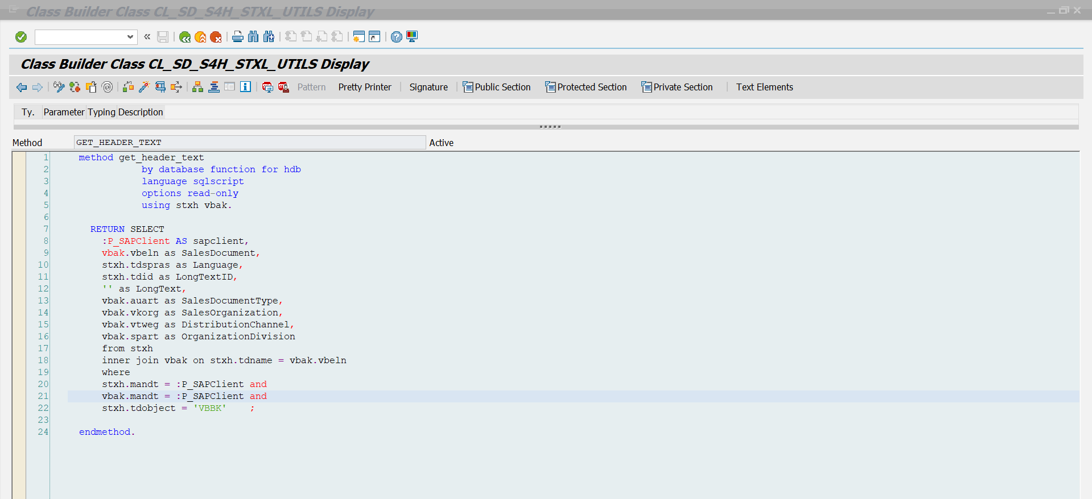

Transfer auth. info from application to new persistency class

To transfer the authorization related info from application to new persistency class, the field text title in text header will be used (THEAD-TDTITLE), becuase authorization related fields are applciation specific, not part of framework interface.

It is comfirmed from text framwork colleague Rene Zink, application could reuse this field to transfer the application related data, and the text title field is language dependent.

For Sales document, the following authorization fields’ information will be transferred.
- SD Document Category.
- Sales Document Type, language independent code from table TVAK, the value is fetched from VBAK-AUART.
- Sales Organization.
- Distribution Channel.
- Division.

Since only one field(text title) is used for transferring the value from 5 Sales fields, we need to combine value from 5 fields into one field, we have following two options to build(encode) the transftered value.
- Option 1 (prefrred option, used this option after alignment with Toralf and Thomas), concatenating values with respecting blank and without separator, sequence is: SD Document Category + Sales Document Type + Sales Organization + Distribution Channel + Division, example: ‘C TA 10001000’.
  - Pros: this pattern is commonly used in existing design, e.g. ADRV-APP_KEY, C_ChangeDocuments.
  - Cons: leading blank conversion is needed, this may decrea performance.s
- Option 2, concatenating values without repsecting blank and with separator(e.g. ‘-‘), sequence is: SD Document Category + ‘-’ + Sales Document Type + ‘-‘ + Sales Organization + ‘-‘ + Distribution Channel + ‘-‘ + Division.
  - Pros: logic is simple.
  - Cons: it is hard to decide which separator should be used, as the customer may already use the special character in their code, e.g. ‘-’.

The form SAVE_TEXT in function group V70T needs to be adapted, right before the call to text framework function module SAVE_TEXT, the class cl_sls_data_ref will bed used to retrieve auth info from Sales’ buffer, and the encoded auth value should be assigned to text title field of the text header, then the the auth value will be pass to new persistency class in update session. The fields for referencing document long text of predecessor documents do not play a role in filling auth related fields.

Validation for Billing is done.
PERSIST_TEXT (CL_SDCI_ACCESS) shall be enhanced so the necessary fields (Billing Document Type and Sales Organization) can be passed to the SAVE_TEXT function module.

Validation for Delivery not started.

Copy Controls
Copy/reference is supported by configuration via SSCUI. In SD, the standard content is design for copying text for important text IDs, the following is the screenshot for sales document header. In case user wants to use referenced text, unmarking the field ‘Refer/Duplicate’ is needed.
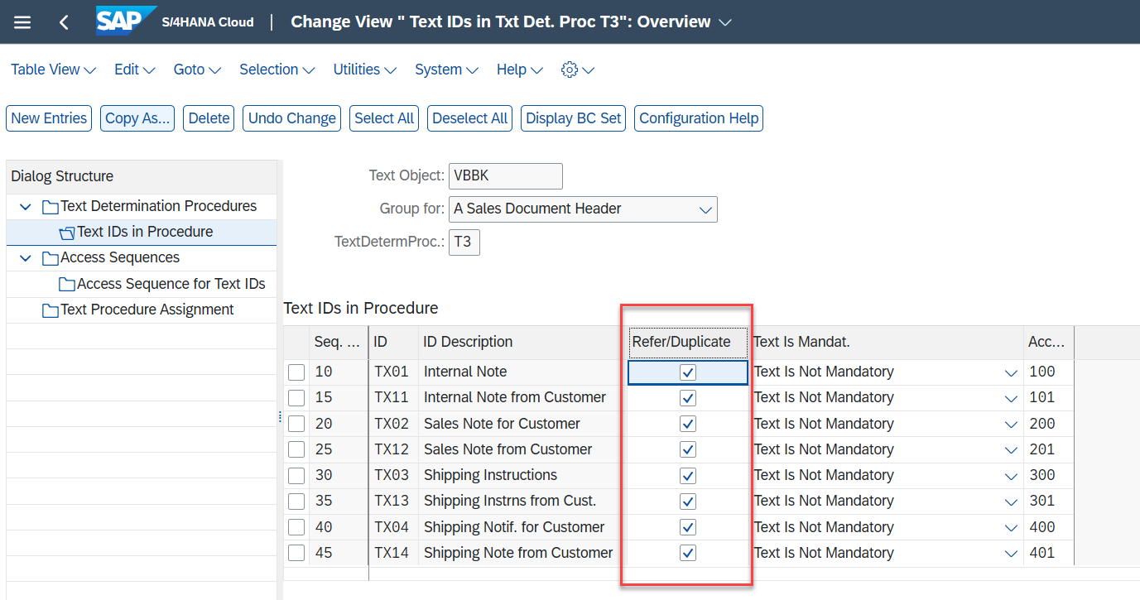

The copy/reference is also supported by text framework when using the application specific persistence. For detail, check wiki https://wiki.one.int.sap/wiki/x/a4QLlQ

For SD text redesign, we have the following two options for copy control.

Option 1: Support copy only.
- Pros:
  - The text content will be stored for each text records, search(SQL) and CDS view are well supported.
  - The CRUD logic is simple, invest effort is lower than option 2.
- Cons:
  - Customers already used to reference scenario will be affected.
Cloud reporting showed that more than 752000000 records exist in VBBK(VBBP) in total and (as of August 2025) ~ 4000000 records with non-VBBK(VBBP) references exist, The reference percentage indicating the impact of affected records is 21,280,582/752,731,587 = 2.83% overall and limited to non-VBBK(VBBP) references the percentage 4,390,140/752,731,587 = 0.58%.
  - Do not support the reference scenario and adjust the configuration is required.

Option 2: Support both copy and reference.
- Pros:
  - Fully support the copy/reference (feature parity), no need to change configuration.
- Cons:
  - For text record with reference, the text content is empty, searching based on text content is a problem for open SQL and CDS view.
  - There are limitations when using text reference, especially in delete case, cross applications/archiving/old and new persistence should be checked. Wiki for archiving https://wiki.one.int.sap/wiki/x/4IoLlQ
  - The CRUD logic is complex, invest effort is higher than option 1.

Silent Data Migration

A new class CL_SDM_SD_VBAK_TEXT_MIGRATION (package SD_BF_TEXT_DET) is implemented as a subclass of CL_SDM_PACKAGE_MIGRATION. (The naming convention is prescribed by the SDM Wiki page.) In general, the following phases can be distinguished during the conversion with respect to SDM-execution in the upgrade to a new main release:

Phase | Description
Phase 1: Before the upgrade | - The standard behavior in the preceding release is applied without any changes. Text CRUD happens on old persistence only.
Phase 2  After upgrade, but before the SDM is finished. | - Text read happens on old persistency only.  - Text CUD happens on both old persistency and new persistency.
Phase 3: SDM is finished | - All texts are converted  - Text CRUD happens on new persistence only.

Since there is a parallel SDM development (2602 SDM for SDSLS_SOFI) for table VBAK in another team, this means ‘03’ may not be the final SDM version value for text migration, depend on delivery sequence and release, the SDM value should be discussed with relevant teams and the method IF_SDM_MIGRATION~GET_PREREQUISITES of SDM class will also be impacted in case the dependency exists.

In the PoC, we do not do updates to VBAK-SDM_VERSION, in any system, this would clash with the 2602 SDM for SDSLS_SOFI and jeopardize the execution of that SDM in inhouse systems

IF_SDM_MIGRATION~MIGRATE_DATA

At the very beginning of this method, the header data from VBAK / VBRK / LIKP will be fetched according to SDM design, the value from auth fields could be fetched in the same SQL, the means no additional SQL is needed. Later when preparing the text records to be interted in the SD new text table SDTP_TEXT, the auth info should be merged into the text records.

As the text objects VBBK and VBBP are shared, there are multiple options how an SDM can be build:

Item | Description
Option 1  (preferred option) | Create three SDMs, one for VBAK, one for VBRK, and one for LIKP, and set different SDM version values for the three tables, e.g. VBRK is 5, VBAK is 3.  Pros:  - The SDM data source design is simple.  Cons:  - The development and maintenance effort is huge in the case of three SDMs.  - More discussion/effort is needed to algin the ownership of three SDMs, especially for Delivery and Billing area.  - There is no SDM version field in table LIKP.  - Requires application coding change to set the SDM version in the header table.  - Need special logic for the text migration based on document ID, since for some documents, maybe partial text entries have already been stored in new table, SDM need to handle such ‘partial’ cases.  - Additional DB access on header tables required.
Option 2 | Build one P view from STXH with filter text object on VBBK and VBBP, in the meaning time excluding the data from new text table, a virtual SDM version field, only one SDM is needed. PoC CDS view in C50 is P_SDM_SD_LONG_TEXT.  Pros:  - No adaptation is required from the application side.  - Only one SDM is needed, less development and maintenance effort required.  Cons:  - The P view’s logic is complex and STXH is a big table, the performance of the P view will be a potential issue for SDM Monitor app. Similar case CL_SDM_SDSLS_VBAP_2.
Option 3 | Build one P view which union all the data from VBAK, VBRK and LIKP with different filter values on SDM version filter, a virtual SDM version field.  Pros:  - Only one SDM is needed, less development and maintenance effort required.  Cons:  - There is no SDM version field in table LIKP.  - Requires application coding change to set the SDM version in the header table.  - Need special logic for the text migration based on document ID, since for some documents, maybe partial text entries have already been stored in new table, SDM need to handle such ‘partial’ cases.  - Additional DB access on header tables required.  - The performance of the P view will be a potential issue for SDM Monitor app. Similar case CL_SDM_SDSLS_VBAP_2.

Option 1 is the preferred solution, a utility class should be built to encapsulate the reused logic for the three SDMs.

Lock mechanism during the text migration in uptime.
Item | Description
Option 1 | Check the existing locks on documents, SDM will only process the documents without locks. This pattern has already been used in many SD SDMs, e.g. CL_SDM_SDSLS_VBAP* and CL_SDM_SD_VBPA*.  Pros:  - Do not require more system resources for setting locks.  Cons:  - There may be documents locked by other user/application after checking existing locks, exceptional/potential issue on data inconsistence, checking the existing locks as late as possible. But even checking the lock late, there is a slight chance of concurrency issues.
Option 2  Preferred option. | Implement the locks for the documents which texts will be processed by SDM, and unlock after the mass updates in SDM execution, the package size is very small, e.g. 100. This design is used in CRM text migration.  Pros:  - The data consistency is ensured by setting lock.  Cons:  - End user could not edit the SDM locked documents until the SDM execution is finished for the dedicated package.  - More system resources are needed for locks set by SDM.

In this case, option 2 to lock the documents is the preferred option. Based on other SDMIs for large volume tales in the past, it is not expected that the objects will be locked for a longer time. All the texts selected via the SAPscript API SELECT_TEXT which returns a list of text headers.

The text lines are retrieved via mass processing text APIs and subsequently converted to plain text string. Finally, the lines are inserted as an array into the new text table.

Before inserting all records into the new table, the text entris existing new table for the selected documents will be deleted. This ensures the restart ability of the SDM process. When the SDM aborts or must be restarted for some reason (e.g., there is a program termination due to a bug), it must be possible to restart the SDM from scratch.

Also, the old text records from STXH and STXL are not deleted from the database. This is a safety net – if there is some error in the SDM logic, then it should be possible to start SDM again and correct the records; for this reason, the old records must still be available.

IF_SDM_MIGRATION~MIGRATE_DATA_FINISHED

To check if the migration is finished successfully, a selection will be triggered to check header table(VBAK, VBRK and LIKP), to see if there are still header records with SDM_VERSION value lower than the value for migration is done.
- If no record found, the migration is successfully done.
- Otherwise, raise error message.

There is no need to do the mass conversion again to check the text record one by one due to following reasons.
- If we apply the conversion SAPscript -> String, then the probability that the comparison yields a positive result is practically 100% because the same conversion method was already used to produce the string. If the conversion has a problem, this will not be detected with this approach. On the other hand, the conversion used the APIs from text framework, those APIs have been used for a long time and can be deemed essentially error-free.
- If we apply the conversion String -> SAPscript, and the comparison is successful, we can be sure that the text will be displayed in the text editor exactly like it was displayed before the migration. Unfortunately, the comparison is not so easy. In fact, it will fail in many cases if we blindly compare the text format field (TDFORMAT) and the text line (TDLINE). The reason is that a new line (TDFORMAT = ‘/ ‘) is converted to ‘* ‘ by the conversion method SAPscript -> String. Also, an initial format in the first line is converted to ‘* ‘. This implies that the comparison method must be intelligent enough to handle these cases. Still, there are cases where the conversion will yield a text which is different from the original one, but the text displays correctly.The concern is that there will be cases in the customer system which are not recognized by the comparison logic and then result in a false negative which leads to a “failed” status of the entire SDM.
- Mass conversion will again use a lot of time, this will a performance issue for system load.

Remaining methods
IF_SDM_MIGRATION~GET_PACKAGE_SIZE: The value should be chosen in such a way that the migration of one package takes approximately one minute. Some experimenting is required in order to figure out the optimal package size; as an initial value we propose the value 1000.
IF_SDM_MIGRATION~GET_TABLE_NAME: Returns the name of the “root” table which contains the status field, and which is used to select the packages. In this case, the value is VBAK, VBRK and LIKP for the three SDMs.
IF_SDM_MIGRATION~GET_CLIENT_FIELD: Returns the value of the client field, in this case MANDT.
IF_SDM_MIGRATION~GET_SELECTIVE_FIELD: Key selection field for building packages: VBELN.
IF_SDM_MIGRATION~GET_STATUS_FIELD: Returns the field name SDM_VERSION which indicates the migration status of the transaction.
IF_SDM_MIGRATION~GET_STATUS_VALUE_DONE: Returns the code value that represents the status “migration finished”. Using the constent value for SDM version, as SDM SDSLS_SOFI will also be shipped in CE2608, which means the dependeny should also be discussed.
IF_SDM_MIGRATION~MUST_RUN: Always returns abap_true.

Performance considerations
The current amount of data in customer’s productive systems in the two tables is as of 24.01.2025 not considering systems without VBBK or VBBP entries in these tables :
 | VBBK | VBBP
STXH max rows | 6.866.838 | 52.719.956
STXH avg rows | 74.249 | 537.267
STXL max rows | 6.866.838 | 52.719.956
STXL avg rows | 69.901 | 527.570

In order to get some idea about the runtime of the SDM conversion, in 2602 PoC phase, the VBAK SDM class CL_SDM_VBAK_TEXT_MIGRATION_POC was created in DDCI system. Unfortunately, in the DDCI system, there are only 40,853 records in table VBAK, there are 340 VBBK/VBBP records in table STXH. The SDM was executed with package size 30,000, two packages were built during the SDM execution, the following is the SDM runtime information, 17 seconds and 6 seconds were cost by each package. We need to check SDM performance in another system with enough data volume.

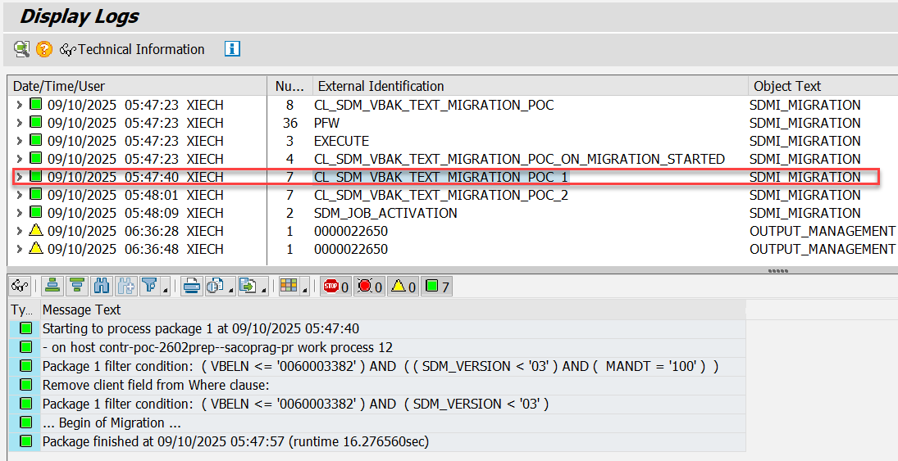

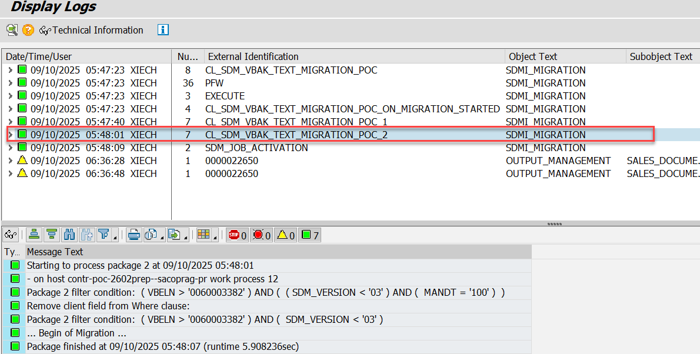

In CCW/720, there are 13,892,774 records in table VBAK and 2,672,483 VBBK/VBBP records in table STXH, the data volume was checked on 2025-09-22. The data volume in CCW/720 is similar to customers’ systems, performance test is performed in this system.

CCW/720 is a central performance test system, according to suggestion from performance expert Juergen Reidl, the SDM test should not used too much work process in parallel and not be executed between 04:00 to 16:00 UTC time.

On 2025-09-22, the first test run executed with package size 30,000, there are 464 packages were built. Usually, it took 8 to 15 seconds to process each package, for the first package it took 494 seconds, because the SDM initialization and data valumn to be processed. In total, it used 3.5 hours to migrate 1,826,035 VBBK/VBBP text records from text framework tables to new text table for SD.
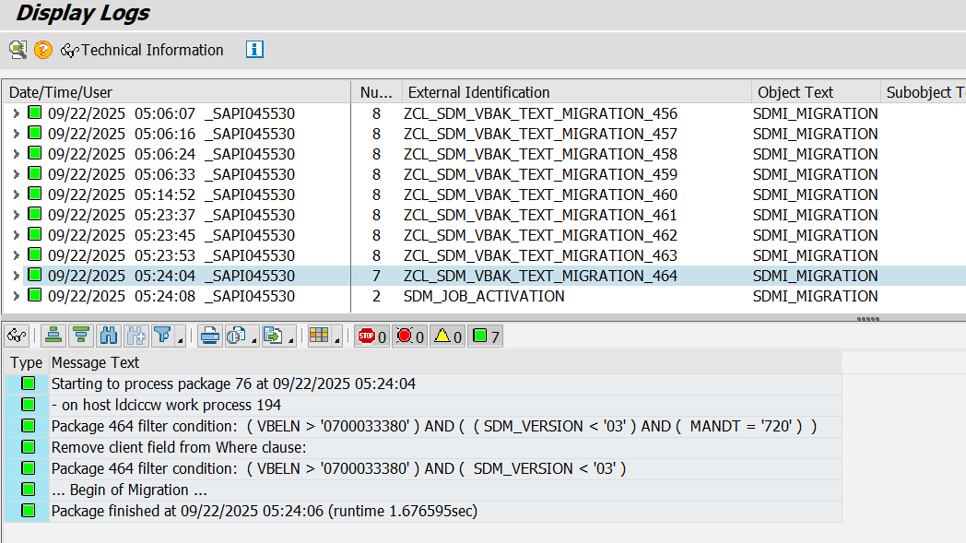

Mass text conversion(mass read) is also considered in performance testing in CCW/720. There are two APIs for mass reading, FM READ_MULTIPLE_TEXTS and FM READ_TEXT_TABLE. The following paragraph describ the performance tests in a nutshell.

CCW/720 data volume on 2025-11-21.
Data Volume | Item
13,941,916 | VBAK
65,198,314 | STXH
2,702,390 | STXH for VBBK and VBBP
1,826,104 | STXH for Sales’ VBBK and VBBP

FM READ_TEXT. Firstly, FM SELECT_TEXT should be used to get text headers’ info, because FM READ_TEXT needs text header info as input to retriveve text content info from old persistence table.
Execution Datetime | Detail info.
2025-09-22 03:11:38 | - Package size 30000, 464 packages.  - 03:11:38 -> 05:24:08, 2 hours 13 minutes.

FM READ_MULTIPLE_TEXTS.
Execution Datetime | Detail info.
2025-11-10 02:03:35 | - Package size 30000, 465 packages.  - 02:03:35 -> 03:58:24, 1 hour 55 minutes.
2025-11-13 02:52:57 | - Package size 32000. 436 packages.  - 02:52:57 -> 04:43:26, 1 hour 51 minutes.
2025-11-13 06:21:19 | - Package size 32000, 436 packages.  - 06:21:19 -> 07:30:40, 1 hour 9 minutes.

FM READ_TEXT_TABLE. Firstly, FM SELECT_TEXT should be used to get text headers’ info, because FM READ_TEXT_TABLE needs text header info as input to retriveve text content info from old persistence table.
Execution Datetime | Detail info.
2025-11-19 01:17:48 | - Package size 32000.  - The migration process was terminated when processing package 252 due to client copy.
2025-11-19 02:42:11 | - Package size 32000, 436 packages.  - 02:42:11 -> 04:39:35, 1 hour 57 minutes.
2025-11-21 02:21:29 | - Package size 32000, 436 packages.  - 02:21:29 -> 03:45:13, 1 hour 24 minutes.

For package size, the range table is used by text framework APIs to retrieve text header and content, due to Open SQL limitation, the upper limitation for range table in where clause is 32767, so the package size is set to 32000 to avoid the SQL dumps. The afftected API are FM READ_MULTIPLE_TEXTS and FM SELECT_TEXT.

In order to improve the performance, the packaging logic is built in method IF_SDM_MIGRATION~MIGRATE_DATA when calling the FM SELECT_TEXT for every 30,000 documents, this mean more text headers could be passed to FM READ_TEXT_TABLE. The following is the execution info after adding the packaging logic.
Execution Datetime | Detail info.
2025-11-25 01:51:16 | - Package size 150,000.  - The migration process was terminated when processing package 31 due to client copy, 01:51:16 -> 02:22:55, 32 minutes.
2025-11-25 02:33:58 | - Package size 150,000.  - The migration process was terminated when processing package 85 due to dump on exceed session memory quota, 02:33:58 -> 04:07:21, 1 hour 33 minutes.  - Each package used 60 to 75 seconds.
2025-11-25 04:14:54 | - Package size 150,000.  - The migration process was terminated when processing package 85 due to dump on exceed session memory quota, 04:14:54 -> 05:46:45, 1 hour 32 minutes.  - Each package used 60 to 75 seconds.
2025-11-26 05:35:49 | - Package size 50,000, 279 packages.  - 05:35:49 -> 06:51:25, 1 hour 16 minutes.
2025-11-27 01:39:13 | - Package size 100,000.  - The migration process was terminated when processing package 127 due to dump on exceed session memory quota, 01:39:13 -> 02:38:49, 59 minutes.
2025-11-27 03:00:22 | - Package size 70,000, 200 packages.  - 03:00:22 -> 04:08:48, 1 hour 8 minutes.

In order to avoid the session memory issue, the internal packaging logic also built for call on FM READ_TEXT_TABLE for every specified number of text headers.
Execution Datetime | Detail info.
2025-12-01 02:45:45 | - Package size 100,000, 140 packages.  - Internal package size for FM SELECT_TEXT is 30,000, internal package size for FM READ_TEXT_TABLE is 400,000.  - 02:45:45 -> 03:58:57, 1 hour 13 minutes.
2025-12-02 02:27:37 | - Package size 50,000, 279 packages.  - Internal package size for FM SELECT_TEXT is 30,000, internal package size for FM READ_TEXT_TABLE is 200,000.  - 02:27:37 -> 04:18:09, 1 hour 51 minutes.
2025-12-09 03:20:52 | - Package size 500,000, 28 packages.  - Internal package size for FM SELECT_TEXT is 30,000, internal package size for FM READ_TEXT_TABLE is 200,000.  - 03:20:52 -> 04:28:10 , 1 hour 8 minutes.

Based on implementation on 2025-12-02 02:07:37, the following statements are used according to the guidence from wiki Silent Data Migration - Cloud Guidance.
DATA(lv_where_condition) = cl_shdb_pfw=>packsel2where( is_packsel ).
lv_where_condition = cl_abap_dyn_prg=>escape_quotes_str( val = lv_where_condition ).
Execution Datetime | Detail info.
2025-12-19 02:54:52 | - Package size 50,000, 279 packages.  - Internal package size for FM SELECT_TEXT is 30,000, internal package size for FM READ_TEXT_TABLE is 200,000.  - 02:54:52 -> 04:43:32, 1 hour 49 minutes.
2025-12-23 02:58:55 | - Package size 1,000 per SDM guideline.  - 13,945 packages.  - Internal package size for FM SELECT_TEXT is 30,000, internal package size for FM READ_TEXT_TABLE is 200,000.  - 02:58:55 -> 04:41:20, 1 hour 42 minutes.
2025-12-24 01:57:25 | - Package size 1,000 per SDM guideline.  - The SDM process terminated due to client copy active when processing package 3357.
2025-12-26 02:30:27 | - Package size 1,000 per SDM guideline.  - 13,946 packages.  - Internal package size for FM SELECT_TEXT is 30,000, internal package size for FM READ_TEXT_TABLE is 200,000.  - 02:30:27 -> 04:20:11, 1 hour 50 minutes.

Handling of the SDM-version fields in the Applications
Documents will be created, updated or deleted during the different phases of the SDM (see chapter 3.5 for details on the phases). This section describes how the applications shall handle the SDM_VERSION-field during these phases in the different CRUD-cases.

If a document is created, changed or deleted in phase 1 before the upgrade the documents shall behave as usual in the starting release. Using the current release as example field SDM_VERSION for VBAK will be set to 03 for change and creation and the texts are only saved in STXH and STXL using the normal text APIs. For deletion, SDM plays no role.

After the upgrade in phase 2 where the SDM is not finalized for all documents, the behavior needs to be:
- If a document is created after upgrade, SDM_VERSION shall be set to the target version with SDM version constant, and the text will be saved in both new and old persistence.
- If a document is changed, the old SDM version value will not be changed, and newly added texts will be saved in both new persistency and old persistency.
- If a document will be deleted, of course all SDM information and texts are gone.

If the SDM is finalized, all old text records have been converted to the new persistency and the SDM version will be set to target version for all documents indicating that the migration is finalized.

To achieve these patterns, the following coding changes are proposed for Sales Documents:
Currently, method cl_sd_sls_analytics=>fill_vbap_olap is called in both update function modules RV_SALES_DOCUMENT_ADD and RV_SALES_DOCUMENT_UPDATE to set SDM version for table VBAK.
- Option 1: The only field that may be possible to distinguish change/create mode is is_vbak-updkz. A new parameter could be added to the method for create/change mode.
- Option 2: Move the SDM_VERSION assignment from the class to the subroutine rv_sales_document_upd and rv_sales_document_add_f, the reason is the method cl_sd_sls_analytics=>fill_vbap_olap is used for fill VBAP’s analysis fields (SDM version 02), now we have different purpose, so setting SDM version via this method is not suitable. Preferred option.

Application coding changes for Billing Documents (table VBRK):
Currently all VBRK entry gets the SDM_VERSION ‘04’ (if_sdm_sdbil_common=>latest_sdm_version). It is set in RV_INVOICE_POST / CL_SDBIL_VBRP_ANALYTICS=> COPY_ANALYTICS_FIELDS, then later in RV_INVOICE_POST / VBRK_BEARBEITEN. Constant if_sdm_sdbil_common=>latest_sdm_version would need to be increased.
New value would need to be added to constant if_sdm_sdbil_common=>sdm_classes to specify the migration class
VBRK_BEARBEITEN would need to be changed, so that only in Create mode, the SDM_VERSION would be automatically set to the latest version.
Application coding change for LIKP (Delivery) should follow a similar pattern but was not evaluated in detail as it is not part of the PoC and delivery teams cannot participate due to capacity limitations.

Archiving (not in 2602 PoC scope)
The new text table(s) VX_TEXT(VBR<x>_TEXT has to be integrated into the archiving functionality. Archiving relies on central function modules which work for SD documents.

Function group VX_TEXT_AC
A new function group VX_TEXT_AC is required which handles selection, writing to the archive, deletion, and retrieval from archive. The function group contains the following function modules:
- VX_SD_TEXT_PRESELECT_AC: Selects the records from VX_TEXT for a given set of transactions.
- VX_SD_TEXT_SAVE_AC: Writes the records selected by VX_TEXT_PRESELECT_AC to the archive.
- VX_SD_TEXT_DELETE_AC: Deletes those records which have been written to the archive by VX_SD_TEXT_SAVE_AC from the database.
- VX_SD_TEXT_READ_AC: Reads the records from the archive and puts them to the buffer of class CL_SD_TEXT_PERSISTENCY.

Adjustments of the archiving objects
The new text table(s) VX_TEXT must be entered in all archiving objects of the sales processes (transaction AOBJ, node “Structure Definition”) where they are used. If only one table is used across the chain, this table has to be entered into archiving objects …
The table must be entered at the bottom in the column “Segment”. The field “Parent Segment” remains empty.

Integration into the VDM and RAP models

Basic view on the new text table

The new basic CDS view on the new table is depicted below. This is the currently implemented version with no self join; the view name as well as all global field names have not been approved, they will be requested in CE2608 development.

Due to the reference chain desgin, it is expected to build one level self-join to support SD internal reference text retrival, the desgin is like CRM solution. Since the data volume in SD much higher than CRM applications, additional CDS view performance is planned, if the performance is acceptable, we will deliver the interface view with one level self-join.

Since there are no authorization fields in the new table, DCL0 will be used to protect the basic view(first level CDS view). For upper level CDS views, for example sales text CDS view, join I_SalesDocumentBasic is needed to filter sales document texts and build sales related DCL. Following the same pattern of table VBPA.
There is only one central text table for SD, a basic view could be created that contains all the projected fields from new SD text table.

@EndUserText.label: 'SD Document Complete Texts'

@ObjectModel.usageType.dataClass: #TRANSACTIONAL // Different from I_TextObject
@ObjectModel.usageType.serviceQuality: #A
@ObjectModel.usageType.sizeCategory: #L

@VDM.viewType: #BASIC
@AccessControl.authorizationCheck: #PRIVILEGED_ONLY // Different from I_TextObject

// I_TextObject is the framework CDS view, the GFNs could be reused.
define view entity I_SDDocumentText
as select from sddoc_text_poc
association [0..1] to I_TextObjectCategory as _TextObjectCategory
on $projection.SDDocumentTextObjectCategory = _TextObjectCategory.TextObjectCategory
association [0..1] to I_TextObjectType as _TextObjectType
on $projection.SDDocumentTextObjectType = _TextObjectType.TextObjectType
and $projection.SDDocumentTextObjectCategory = _TextObjectType.TextObjectCategory
association [0..1] to I_Language as _Language
on $projection.Language = _Language.Language
{
key sddoc_text_poc.sd_text_uuid as SDDocumentTextUUID,

// Text framwork keys
sddoc_text_poc.text_name as SDDocumentTextObjectKey,
@ObjectModel.foreignKey.association: '_TextObjectCategory'
sddoc_text_poc.text_object as SDDocumentTextObjectCategory,
@ObjectModel.foreignKey.association: '_TextObjectType'
sddoc_text_poc.text_id as SDDocumentTextObjectType,
@Semantics.language: true
@ObjectModel.foreignKey.association: '_Language'
sddoc_text_poc.language as Language,

// Text content
sddoc_text_poc.mimetype as MIMEType,
sddoc_text_poc.text_content as TextContent,

// SD Document keys
sddoc_text_poc.sd_document as SDDocument,
sddoc_text_poc.sd_document_item as SDDocumentItem,

// Reference Info
sddoc_text_poc.ref_text_name as ReferenceLongTextKey,
sddoc_text_poc.ref_text_object as ReferenceTextObjectCategory,
sddoc_text_poc.ref_text_id as ReferenceTextObjectType,

// Admin info
sddoc_text_poc.created_at as CreationDateTime,
sddoc_text_poc.created_by as CreatedByUser,
sddoc_text_poc.changed_at as LastChangeDateTime,
sddoc_text_poc.changed_by as LastChangedByUser,

_TextObjectCategory,
_TextObjectType,
_Language
}

Analytics CDS view

A new analytics CDS view will be built upon the basic view descriped on chapter 3.7.1. This CDS view will be assigned will analytical related annotations, e.g. data extraction, then this CDS view couls be used in data parts and BW scenario.

This is CDS will be C1 released, so that the consumer could consume it based on their business needs.

Integration into the RAP models

Currently the reference text could not be resolved by newly defined CDS views in section 3.7.1, so it is not planned to integrate it into existing RAP models which are using table function CDS views, since we could not achieve feature parity. The table function CDS view is P_SalesDocumentText, the related AMDP class is CL_SD_S4H_STXL_UTILS.

But the data source table of table function CDS view will be replaced by the new SD text table after the migration is done, according to the design, after the migration is done, all the new text records will be interted into new text table, not text framework tables.

For the middle term plan (CE2702 and beyond), a transactional purpose CDS view will be built to support 1 level reference resolution, following the samiliar pattern in CRM solution(CDS view I_ServiceDocumentLongText), since there is a limition on supporting reference text, a KBA note will also be provided to consumer to explain the limitation.

Test cases

Text handling in the transaction
- Are text updates, reads and creations correctly handled in VA* transactions?
- Are text updates, reads and creations correctly handled in VF* transactions?
- Are text updates, reads and creations correctly handled in Sales and Billing Fiori apps?

SDM migration
- Does the SDM migration finished method recognize a successful completion?
- Are the texts correctly migrated
It must be checked check whether the contents of the newly created records in VX_TEXT are (semantically) identical to the one in the old persistency.

Archiving (not in 2602 PoC scope)
N.A.

Design challenges

Text CDS views from other LoBs missing

According to cloud reporting, many VBBK and VBBP text records have reference to other text objects in customers’ productive systems, for example, SAP standard text(TEXT), BP(KNVV, KNA1), Material(MVKE, MATERIAL), Purchase Order(EKKO).

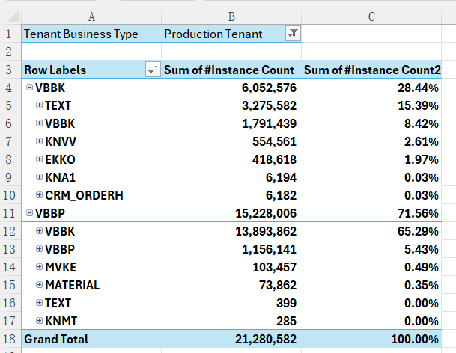

But the text CDS views for TEXT, KNVV, KNA1, MVKE, MATERIAL and EKKO are missing, till now there is no plan when those text CDS views will be available. This is a blocker for SD text CDS view to resolve the text reference which points to text objects other than VBBK and VBBP.
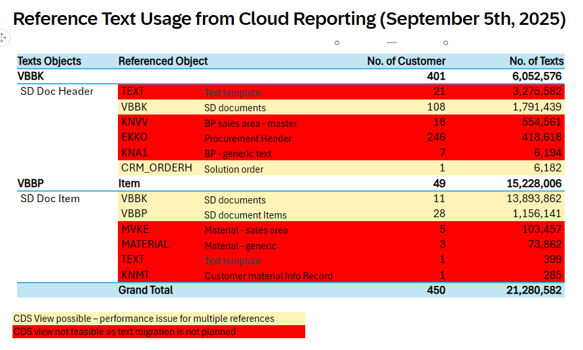

Text Reference Chain

For text entries with reference info, the reference info (text object, text ID, text name) will also be migrated to new persistence.

Reference chain example: Document 1’s text A -> Document 2’s text B -> Document 3’s text C -> Document 4’s text D.

Option | Description
Option 1  Current design in S4.  Preferred option. | The text record stores direct predecessor document’s text info.  In the example above,  - Text record B stores IDs of text record A.  - Text record C stores IDs of text record B.  - Text record D stores IDs of text record C.  Pros:  - Compatible design, the data is the same to the data in table STXH.  Cons:  - Only one level self-join defined in CDS view, only one level reference info retrieval is supported.
Option 2 | The text record stores leading document’s text info.  In the example above,  - Text record B stores IDs of text record A.  - Text record C stores IDs of text record A.  - Text record D stores IDs of text record A.  Pros:  - Easy to build text CDS view via self-join to support reference case.  Cons:  - Additional logic is required to find the leading text record’s IDs and the performance will decrease.  - In case text change happens within document chain, this change could not be reflected in the subsequent documents. For example, text B is changed, the changes could not be reflected in text C and text D. This behavior is different from current system behavior.  - The stored reference text IDs may differ from the data in assigned text access sequence. This may increase complexity when analyzing the issues or auditing.  - If the CDS view is released, customers are hard to understand the reference IDs, since the info in CDS view could be different from text determination log.

If we go with option 1, we still face following challenges, currently there is no possible solution.
- SD documents’ text records may have reference to text objects other than VBBK and VBBP, the SD text CDS view could not resolve the text content by join, since the CDS views of target text objects are missing. For example, if the reference chain is KNA1 -> VBBK, the text CDS view for Business Partner is missing.
- Even if the reference chain is within SD area, we could not foresee how many levels self-joins are required, and this is an also blocker for CDS view design. Only one level self-join is supported in CRM solution. Too many self-joins will lead to increase of complexity and bad performance.

No SDM development for Delivery-documents

Due to capacity issues, no SDM will be delivered in CE2608, probably not even in CE2702, for deliveries by the responsible unit which would lead to the following impact:
- The overall SD text migration status is in process until the SDM for delivery documents has been executed successfully. As this status will be used by SD text handler class and therefore the text framework will continue to create/update/delete data in both old persistence and new persistence. This leads to an increase of TCO and maintenance effort.
- Applications from Sales and Billing still reading the old persistence via standard text APIs will be switched to new persistence once Delivery’s SDM is executed successfully in later releases. This later switch will lead to additional testing effort for Sales and Billing.
- The new persistence contains no text data for delivery documents, this will cause additional issues in resolving reference data within SD process flow, for example from Billing to Delivery (see also chapter 2.1.3). Texts for delivery documents can not be extracted so customers can only extract data for some documents involved in the quote to cash document flow.

Open questions and topics
- Archiving was not evaluated in detail as the PoC was focusing on the conversion, usage and potential limitations of the new text persistency within the existing boundary conditions. To finalize a MVS including archiving details for VX_SD_TEXT_SAVE_AC, VX_SD_TEXT_DELETE_AC, and VX_SD_TEXT_READ_AC (see chapter 3.6.1) need to be defined.
- What’s the effort for LE, since LE will not join the productive development in CE2608.
  - Adding field SDM_VERSION to table LIKP.
  - Adjusting the application coding to fill SDM_VERSION for new deliveries.
  - Developing the text migration SDM for table LIKP. SDM Guideline.
  - Adjust the CDS views to adopt the new text table after migration is done.
  - Testing on application and SDM.
  - Adopt archiving.
- Due to the design challeges decribed in 3.9.1 and 3.9.2, currently it is not possible to build a transactional SD text CDS view to support RAP / Fiori / API, the following steps needed to achieve the idealy state, in this state the table function should still be used for reference retrival, since text CDS views for external text objects are missing and protential performance issue from CDS join.
  - Step 1, the texts from delivery are migrated by SDM.
  - Step 2, replace the data source table from STXH to new SD text table in table function view for SD text.

References

Document Title | Link
SDD Template and instructions for completing | https://wiki.wdf.sap.corp/wiki/pages/editpage.action?pageId=2051281296
Project Folder | 05_Text_Redesign
CIP-Request | https://influence.sap.com/sap/ino/#/idea/284380/?section=sectionDetails
JIRA | S4HCRQMASD-38292
ACD
Central WIKI page for application texts | https://wiki.one.int.sap/wiki/x/HpZOl
SDMI reference information | Silent Data Migration - Cloud Guidance - S/4HANA - Wiki@SAP

Document History

Version | Status | Date | Reviewer /Approver
0.1 | Draft | 13.01.2025 | N/A
1.0 | Reviewed | 01.12.2025 | Colleagues from Sales and Billing
2.0 | In Progress | 19.01.2026

For 2.0 version, the main change is about new fields in SD text table SDTP_TEXT and its logic, the following chapters are changed and need to be reviewed.
- Chapter 2.3, this part describes the which fields will be added to SD text table SDTP_TEXT.
- Chapter 3.1.3, this part describes how to persist the auth info in SD new text table SDTP_TEXT by new persistency class.
- Chapter 3.3.2, this part describes how to transfer the authorization info from application to new persistency class.
- Chapter 3.5.1, this part describes how the SDM migrate the auth info in a mass way.

